# 

# PROJECT REPORT

## On

**Bus Management System**

Submitted in partial fulfillment of the requirement for the Course Lab Oriented Project (CSP4401) of

## COMPUTER SCIENCE AND ENGINEERING

**B.E. Batch-2016**

**in**

**November-2019**



|  |  |
| --- | --- |
| **Under the Guidance of:** | **Submitted By:** |
| Ms Nidhi | **Preet Singh** |
|  | **1611981282** |
|  | **Rahul Sharma** |
|  | **1611981292** |
|  | **Rahul Kumar** |
|  | **1611981291** |
|  |

**DEPARTMENT OF COMPUTER SCIENCE & ENGINEERING**

**CHITKARA UNIVERSITY**

**HIMACHAL PRADESH**

**CANDIDATE’S DECLARATION**

We, **RAHUL SHARMA (ID: 1611981292), PREET SINGH (ID: 1611981282), RAHUL KUMAR (ID: 1611981291),** B.E.-2016 of the Chitkara University, Himachal Pradesh hereby declare that the Lab Oriented Project Report entitled **“BUS MANAGEMENT SYSTEM”** is an original work and data provided in the study is authentic to the best of our knowledge. This report has not been submitted to any other Institute for the award of any other course.

|  |  |  |
| --- | --- | --- |
| Rahul Sharma | Preet Singh | Rahul Kumar |
| ID No: 1611981292 | ID No: 1611981282 | ID No: 1611981291 |

**Place:**

**Date:**

**CERTIFICATE**

This is to be certified that the project entitled “Bus Management System” has been submitted for the Bachelor of Computer Science Engineering at Chitkara University, Himachal Pradesh during the academic semester July 2019-December 2019 is a bonafide piece of project work carried out by “Rahul Sharma (ID: 1611981292), Preet Singh (ID: 1611981282), Rahul Kumar (ID: 1611981291)” towards the partial fulfilment for the award of the course Lab Oriented Project (CSP4401) under the guidance of “Ms. Nandini” and supervision.

**Signature of Project Guide**

Ms. Nidhi

(Associate Proffessor)

**ACKNOWLEDGEMENT**

It is our pleasure to be indebted to various people, who directly or indirectly contributed in the development of this work and who influenced our thinking, behaviour and acts during the course of study.

We express our sincere gratitude to all for providing an opportunity to undergo Lab Oriented Project as the part of the curriculum.

We are thankful to “Project Guide Name” for his/her support, cooperation, and motivation provided to us during the training for constant inspiration, presence and blessings.

We also extend our sincere appreciation to “Project Guide name and External Guide name (if any) who provided his/her valuable suggestions and precious time in accomplishing our project report.

Lastly, We would like to thank the almighty and our parents for their moral support and friends with whom we shared our day-to day experience and received lots of suggestions that improve our quality of work.

**Rahul Sharma Preet Singh Rahul Kumar**

**1611981292 1611981282 1611981291**

**TABLE OF CONTENT**

1. **Abstract 1**
2. **Introduction to the project 2**
   1. **Problem Statement 2**
   2. **Project Bckground 2**
   3. **Objective 2**
3. **Software and Hardware Requirement Specification 4**
   1. **Functional Requirements 4**
   2. **Non-Functional Requirements 5**
   3. **Architecture Used 6**
   4. **Programming/Working Environment 7**
4. **Program’s Structure Analysing and GUI Constructing 17**

**4.1 Project Screenshots 17**

1. **System Testing 34**
2. **Conclusion 38**
3. **Future Scope 39**
4. **Bibliography/References 40**

**LIST OF FIGURES**

Figure 1 Waterfall Model 6

Figure 2 Java Servlet Page 7

Figure 3 NetBeans 8

Figure 4 Netbeans 9

Figure 5 Hibernate 12

Figure 6 Hibernate Architecture 14

Figure 7 Hibernate Mapping 15

Figure 8 Student Login 17

Figure 9 Faculty Login 18

Figure 10 Admin Login 19

Figure 11 Admin Dashboard 20

Figure 12 Update Route 21

Figure 13 View Route 22

Figure 14 23

Figure 15 Update Route 24

Figure 16 Delete Route 25

Figure 17 Faculty Details 26

Figure 18 Student Details 27

Figure 19 Student Dashboard 28

Figure 20 Faculty Dashboard 29

Figure 21 Student Information 30

Figure 22 Route Info 31

Figure 23 Search Results 32

Figure 24 Sign-Up 33

**LIST OF TABLES**

Table 1 Shows system test plan and results 37

**Chapter 1 ABSTRACT**

Bus Management System is an integrated electronic management system. This system ensure that the management process of this can company are smoothly done. This system will also help in decreasing error mostly cause by human mistake. This system was developed as one of the solution to transfer from current manual practices to a more systematic computerized system. This system will be developed by using Java and Hibernate. Briefly there are two main modules for this system. The first module will be the Driver Management module and the second module will be Bus Management Module. However this report will just describe about Bus Management Module. In this module, the function that will be developed include, bus registration, maintenance record, and reminder.

Bus Transport Management System project is developed for making present system of bus transportation paperless and more digitalized. This will make easy of business due to user friendly and easy to use system. Utilization of this system will increase the productivity. The main moto of this is to provide transport service to consigner and consignee. As due to computerization billing, summarized payment, creating report etc. will be permanently stored and will be easily available whenever need in future. Consequently this will also decrease the work load in the office resulting in having more time investment in other productive tasks. Security and potential of the business also increases. Proper management and analysis can be done with the help of data stored and generated due to implementation of this digitalized system

**Chapter 2 INTRODUCTION**

**2.1 Problem Statement:**

In the existing system Colleges have to manually maintain information regarding College busses and routes. Information relating to student passengers and bus passes have to be maintained separately.

Need for System :

1. Provide a simpler method to store and access information related to buses and students.
2. Provide a simple interface which will be easily used without much training.
3. Reduce paperwork and make all related information accessible easily.

**2.2 Project Background:**

The Bus Management System is being developed to provide a tool for the different colleges to easily maintain the college bus information. The system will give an effective output for the Java & Microsoft excel given as input to the system. The compiled java program given as input to the system, after scanning the program will generate different reports.  
At the start of the project setup, Microsoft Access provides an interactive part to store information about buses; different routs of buses, student information, and bus pass etc.  
  
During the period of finalizing the idea of the system, the primary goal was to design the system i.e those who don’t know how to handle the software. As designing work began and things started taking shape, the system got developed to a stage where it would be used by entry level

**2.3 Objective:**

In this world of growing technologies everything has been computerized. With large number of works opportunities, the Human workforce has increased. Thus, there is a need of a system which can handle the data of such a large number of Employees. This project simplifies the task of maintaining records because of its user-friendly nature.

The objective of this project is to provide a comprehensive approach towards the management of employee information. This will be done by designing and implementing an Employee management system that will bring up a major paradigm shift in the way that employee information is handled.

The objectives of this system include:

* Design of a web-based Bus Management System.
* Well-designed database to store Bus, Student and Faculty information.
* A user friendly front-end for the user to interact with the system.
* To convert the manual into automated system.
* There are three views for this application first is the administrator and the second is student , faculty view.

**Chapter 3 SOFTWARE AND HARDWARE REQUIREMENT SPECIFICATION**

**3.1 Functional Requirements :**

**3.1.1 Authentication**

* Login- The user can login to the employee system with his/her username and password.
* Logout- The user can log out from the employee system.
* Login failure- If the user does not exist in the database or the user has not yet being authorized by the admin.

**3.1.2 Authorization**

* User role check- After logging in, the user role will be checked from the database and the user interface will be displayed according to their role.

**3.1.3 Process Data**

* Display- User with defined roles can display the content of the database. Being more specific, employee can only view his/her personal information. Admin can not only see his/her personal information but also employee’s information who are under his/her department or school. Admin can display their personal information and all employees’ information.
* **Edit**- A user with employee role can edit his/her specific personal information. Admin can edit employees’ personal information. Admin can edit all information related to all employees’ including their user role type.

Update authentication- This feature can be used only by admin role type. Admin can update the role type of a specific user. Admin will be able to update this authentication mechanism.

**3.1.4 Bus Application/Approval**

* Bus application- The user can be able to fill in sign-up form in the appropriate fields.
* Bus approval- The admin can be able to approve Bus applications based on the records stated.

* 1. **Non-Functional Requirements :**

**3.2.1 Performance Requirements**

There is no restriction on the number of the users to be added to the database.

**Hardware Requirements**

BMS should be able to work on a computer with the following minimum hardware specifications:

OS: Windows XP/Vista/7/8 and Linux

CPU: Pentium III (700MHz) and above

Memory: 128 MB and above

Capacity: 4GB of hard drive

Others: mouse, keyboard, and monitor.

**Software Requirements**

Since BMS application is a web-based application, internet connection must be as an

established.The BMS software database model will support MySQL environment as

DBMS.

**3.3 Architecture Used :**

**The Waterfall Model**

The waterfall model is a sequential design process, often used in software development processes. It takes the fundamental process activities of specification, development, validation, and evolution and represents them as separate process phases such as requirements specification, software design, implementation, testing, and so on.

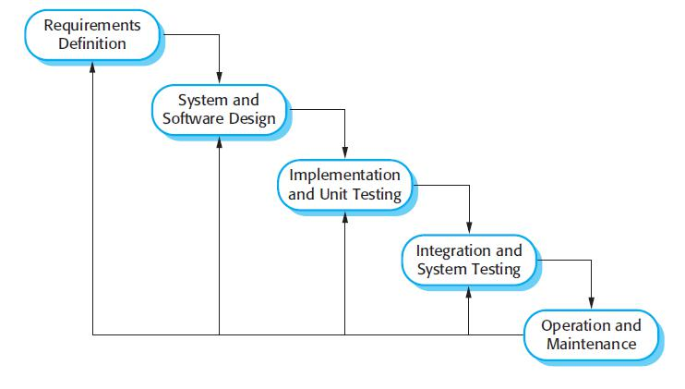

Figure 1 Waterfall Model

In “**The Waterfall**” approach, the whole process of software development is divided into separate phases. The outcome of one phase acts as the input for the next phase sequentially. This means that any phase in the development process begins only if the previous phase is complete. The waterfall model is a sequential design process in which progress is seen as flowing steadily downwards (like a waterfall) through the phases of

**Conception, Initiation, Analysis, Design, Construction, Testing, Production, Implement-ation and Maintenance.**

As the **Waterfall Model** illustrates the software development process in a linear sequential flow; hence it is also referred to as a **Linear-Sequential Life Cycle Model**.

* 1. **Programming/Working Environment :**

**Java Servlet Pages** Java Servlet Pages (JSP) is a technology that helps [software developers](http://en.wikipedia.org/wiki/Software_developer) create [dynamically](http://en.wikipedia.org/wiki/Dynamic_web_page) [generated web pages](http://en.wikipedia.org/wiki/Dynamic_web_page) based on HTML,XML, or other document types. Released in 1999 by [SunMicrosystems,](http://en.wikipedia.org/wiki/Sun_Microsystems) JSP is similar to [PHP,](http://en.wikipedia.org/wiki/PHP) but it uses the [Java programming language.](http://en.wikipedia.org/wiki/Java_(programming_language))To deploy and run Java Servlet Pages, a compatible web server with a [servlet](http://en.wikipedia.org/wiki/Servlet) container, such as [Apache Tomcat](http://en.wikipedia.org/wiki/Apache_Tomcat) or [Jetty,](http://en.wikipedia.org/wiki/Jetty_(web_server)) is required.

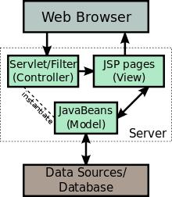

Figure 2 Java Servlet Page

* + 1. **DatabaseUsed:**

**MySQL**

MySQL is an open source database that is platform independent and can easily interface with a number of scripting languages, it works best with PHP though. The number of advantages of using MySQL which include, the ability to handle stored procedures, triggers, SQL and User-Defined functions. It also offers a high-speed data load utility and support for various drivers (ODBC, JDBC, .NET, PHP).

Deploying a MySQL database has proved to be cheap and easy as it doesn’t require special hardware or software requirements, it can work well on any web server but most professionals recommend the apache web server. MySQL is an excellent database to use when developing web-based applications because its platform independent and can easily interface with a number of scripting languages.

* + 1. **Working Environment:**

**NETBEANS**

NetBeans is an open-source integrated development environment (IDE) for developing with Java, PHP, C++, and other programming languages. NetBeans is also referred to as a platform of modular components used for developing Java desktop applications.

NetBeans is coded in Java and runs on most operating systems with a Java Virtual Machine (JVM), including Solaris, Mac OS, and Linux.  
NetBeans manages the following platform features and components:

* User settings
* Windows (placement, appearance, etc.)
* NetBeans Visual Library
* Storage
* Integrated development tools
* Framework wizard

Figure 3 NetBeans

NetBeans uses components, also known as modules, to enable software development. NetBeans dynamically installs modules and allows users to download updated features and

digitally authenticated upgrades. NetBeans IDE modules include NetBeans Profiler, a 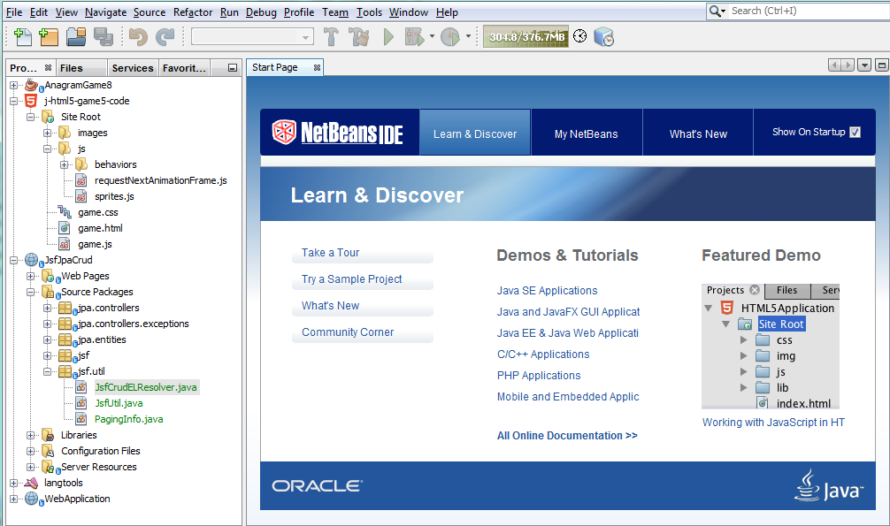

Graphical User Interface (GUI) design tool, and NetBeans JavaScript Editor. NetBeans framework reusability simplifies Java Swing desktop application development, which provides platform extension capabilities to third-party developers.

Figure 4 Netbeans

**Frontend**

Front end-is a term used to characterize program interfaces and services relative to the initial user of these interface and services. It usually refers to the client side of an application. A front end application is one that users interact with directly. Turban et al (2008, p45) defines front end as the portion of an e-seller’s portal, electronic catalogs, a shopping cart, a search engine and a payment gateway.

**3.4.4.1 HTML**

Hypertext Markup Language (HTML) is a computer language devised to allow website creation. These websites can then be viewed by anyone else connected to the Internet. It is relatively easy to learn, with the basics being accessible to most people in one sitting; and quite powerful in what it allows you to create.

Having the basic knowledge of HTML will could help make or develop m-commerce websites and will also prove to be handy especially for editing and modifying web pages. Furthermore, it has some low-cost benefits because of its many free online tutorials and advice support which is vital for m-commerce development.

**3.4.4.2 JavaScript**

JavaScript is a scripting language that is browser based and was developed by Netscape to enable web masters/authors to add interactivity and enhances behavior of web pages. Some of the dynamic behavior that can be generated by JavaScript is validating form, performing specific actions e.g. after a mouse click, adding timestamps etc. JavaScript is an open language and anyone can use it. It also shares m any of the features and structures of the Java programming language, though it is not really related to Java. It was developed independently.

**3.4.4.3 CSS**

CSS is a style sheet language used to describe presentation and layout of HTML tags. CSS is used to enable separation of document content from document presentation. This refers to theseparation of document presentation aspects such as colors, layouts and fonts from the actual document content. CSS helps us achieve layout design and control much easier.

**3.4.4.4 BACKEND**

Backend is server side of the website. It stores and arranges data, and also makes sure everything on the client-side of the website works fine. It is the part of the website that you cannot see and interact with. It is the portion of software that does not come in direct contact with the users. The parts and characteristics developed by backend designers are indirectly accessed by users through a front-end application. Activities, like writing APIs, creating libraries, and working with system components without user interfaces or even .

**3.4.4.5 HIBERNATE**

Hibernate is a high-performance Object/Relational persistence and query service, which is licensed under the open source GNU Lesser General Public License (LGPL) and is free to download. Hibernate not only takes care of the mapping from Java classes to database tables (and from Java data types to SQL data types), but also provides data query and retrieval facilities.

Hibernate is a high-performance Object/Relational persistence and query service, which is licensed under the open source GNU Lesser General Public License (LGPL) and is free to download. Hibernate not only takes care of the mapping from Java classes to database tables (and from Java data types to SQL data types), but also provides data query and retrieval facilities. This tutorial will teach you how to use Hibernate to develop your database based web applications in simple and easy steps.

ORM TOOL : An ORM tool simplifies the data creation, data manipulation and data access. It is a programming technique that maps the object to the data stored in the database.

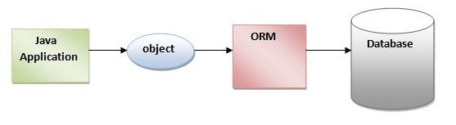

Figure 5 Hibernate

**Advantages of Hibernate Framework**

Following are the advantages of hibernate framework:

1. **Open Source and Lightweight**

Hibernate framework is open source under the LGPL license and lightweight.

**2) Fast Performance**

The performance of hibernate framework is fast because cache is internally used in hibernate framework. There are two types of cache in hibernate framework first level cache and second level cache. First level cache is enabled by default.

**3) Database Independent Query**

HQL (Hibernate Query Language) is the object-oriented version of SQL. It generates the database independent queries. So you don’t need to write database specific queries. Before Hibernate, if database is changed for the project, we need to change the SQL query as well that leads to the maintenance problem.

**4) Automatic Table Creation**

Hibernate framework provides the facility to create the tables of the database automatically. So there is no need to create tables in the database manually.

**5) Simplifies Complex Join**

Fetching data from multiple tables is easy in hibernate framework.

**6) Provides Query Statistics and Database Status**

Hibernate supports Query cache and provide statistics about query and database status

# Hibernate Architecture

The Hibernate architecture includes many objects such as persistent object, session factory, transaction factory, connection factory, session, transaction etc.

The Hibernate architecture is categorized in four layers.

* Java application layer
* Hibernate framework layer
* Backhand api layer
* Database layer

Let’s see the diagram of hibernate architecture: 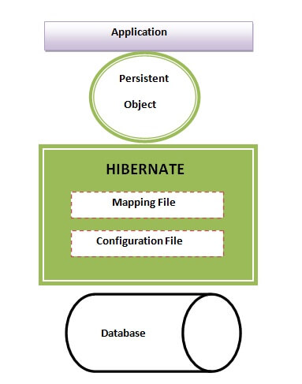

Figure 6 Hibernate Architecture

This is the high level architecture of Hibernate with mapping file and configuration file.

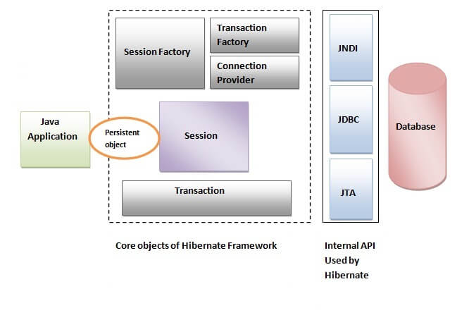

Figure 7 Hibernate Mapping

Hibernate framework uses many objects such as session factory, session, transaction etc. alongwith existing Java API such as JDBC (Java Database Connectivity), JTA (Java Transaction API) and JNDI (Java Naming Directory Interface).

## Elements of Hibernate Architecture

|  |
| --- |
| For creating the first hibernate application, we must know the elements of Hibernate architecture. They are as follows: |

#### SessionFactory

The SessionFactory is a factory of session and client of ConnectionProvider. It holds second level cache (optional) of data. The org.hibernate.SessionFactory interface provides factory method to get the object of Session.

#### Session

The session object provides an interface between the application and data stored in the database. It is a short-lived object and wraps the JDBC connection. It is factory of Transaction, Query and Criteria. It holds a first-level cache (mandatory) of data. The org.hibernate.Session interface provides methods to insert, update and delete the object. It also provides factory methods for Transaction, Query and Criteria.

#### Transaction

The transaction object specifies the atomic unit of work. It is optional. The org.hibernate.Transaction interface provides methods for transaction management.

#### ConnectionProvider

It is a factory of JDBC connections. It abstracts the application from DriverManager or DataSource. It is optional.

#### TransactionFactory

It is a factory of Transaction. It is optional.

**Chapter 4 PROGRAM’S STRUCTURE ANALYZING AND GUI**

**4.1 Project Screenshot :**

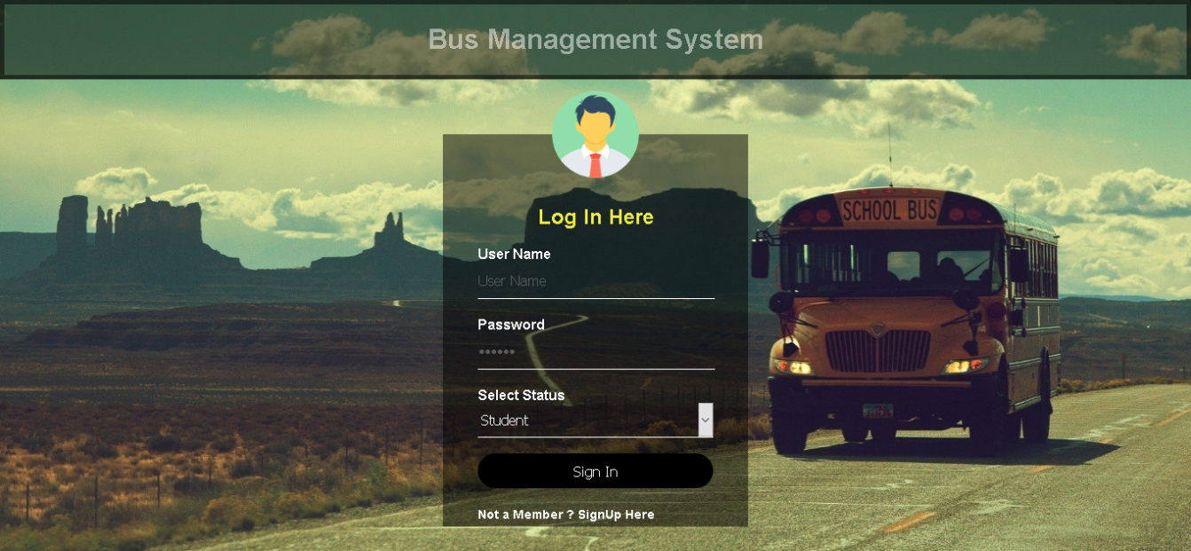

Figure 8 Student Login

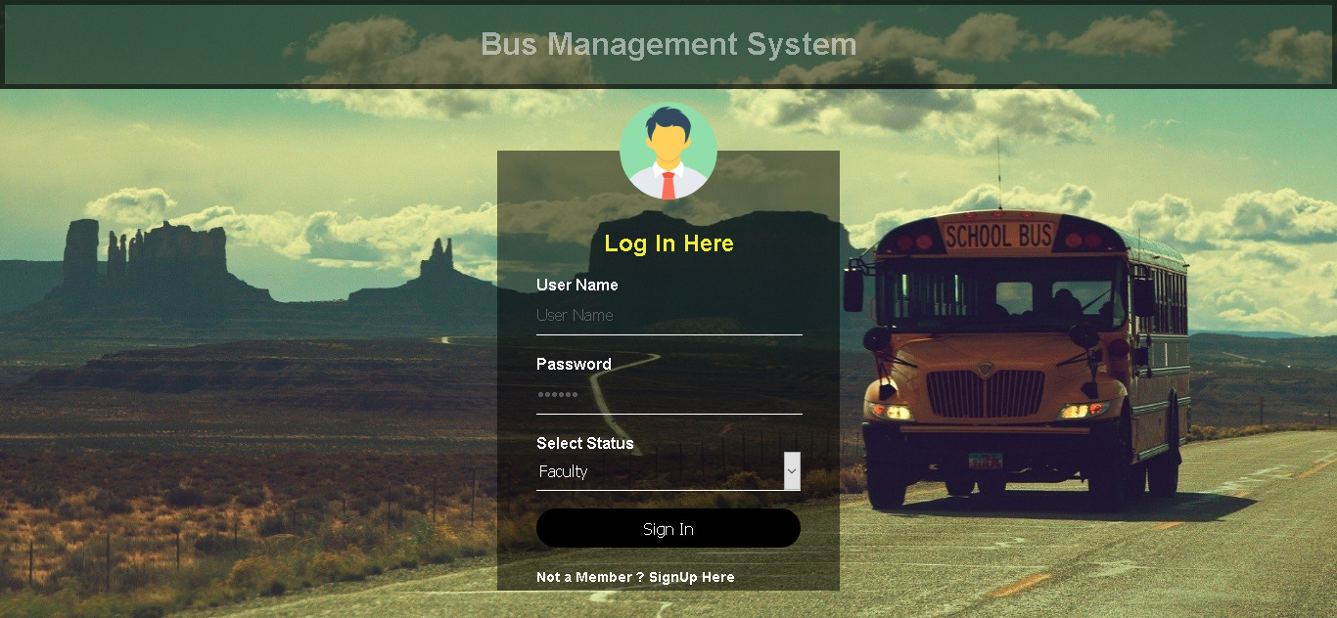

Figure 9 Faculty Login

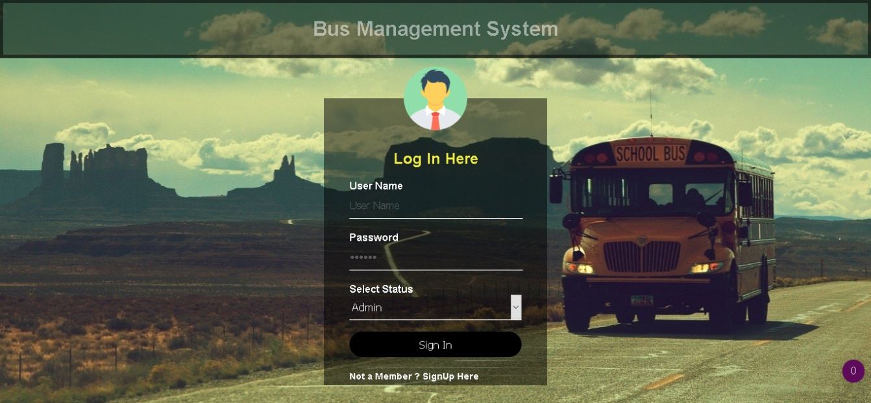

Figure 10 Admin Login

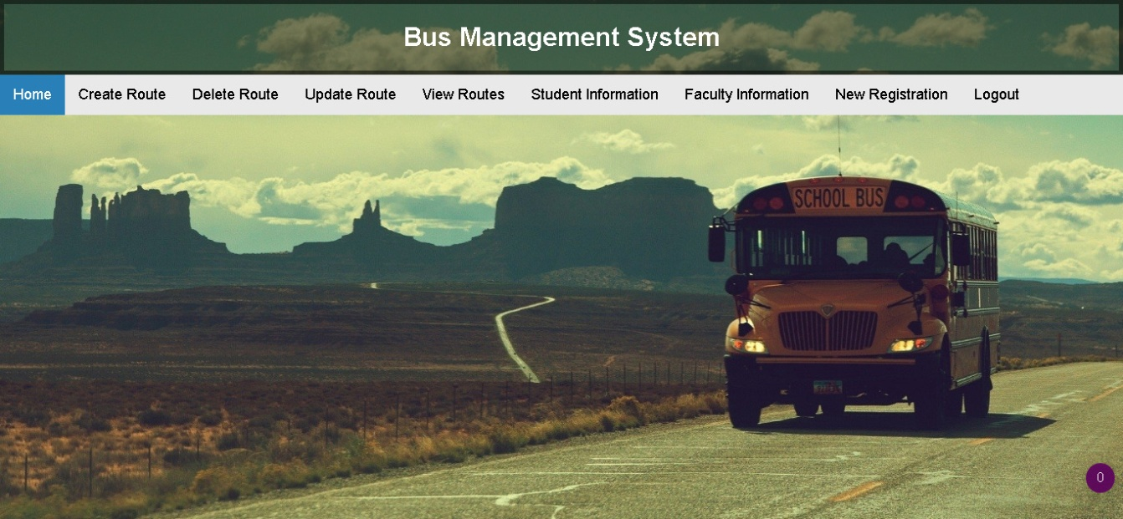

Figure 11 Admin Dashboard

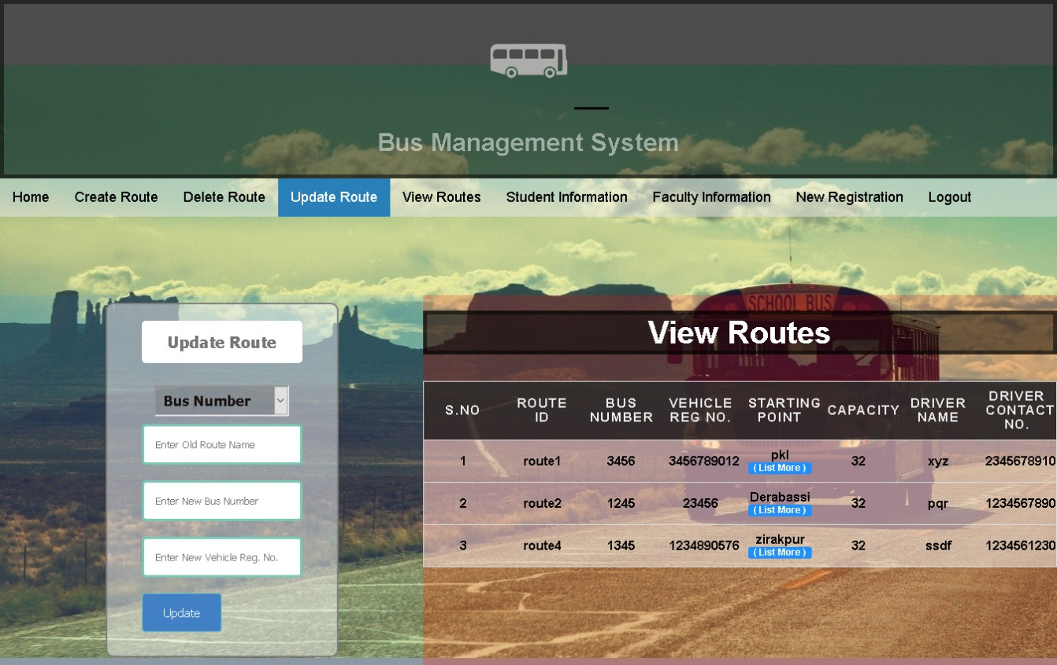

Figure 12 Update Route

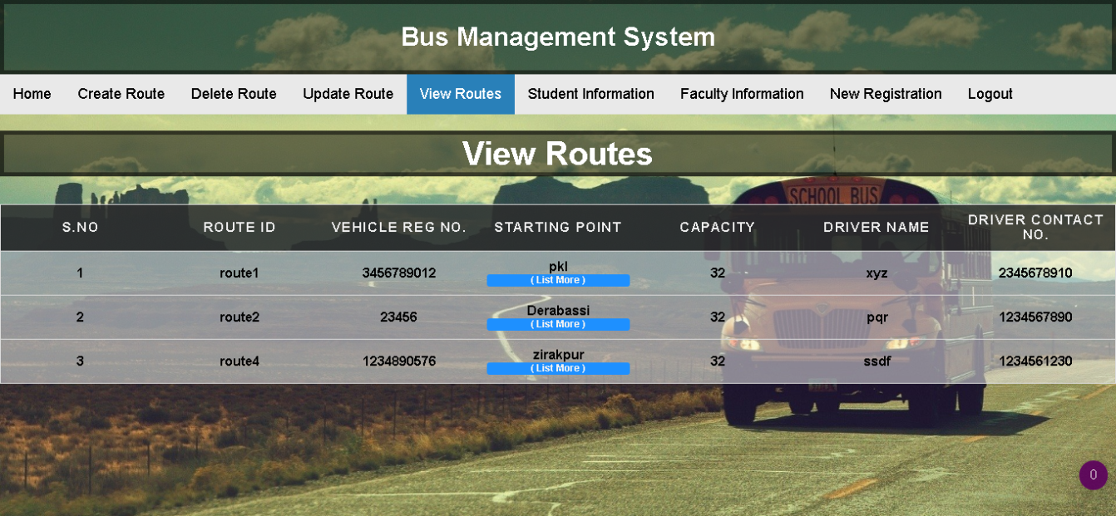

Figure 13 View Route

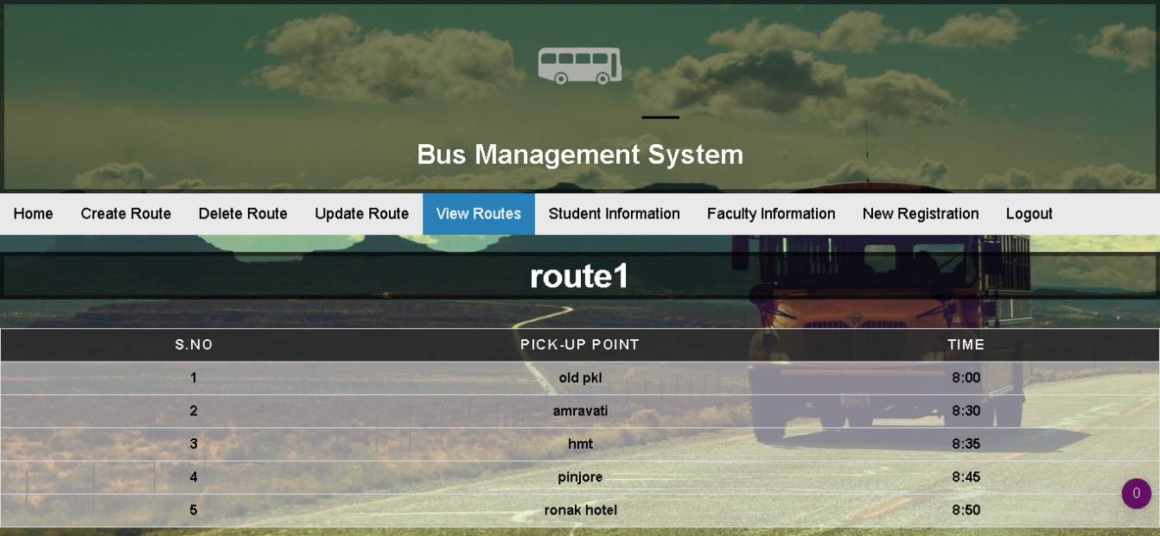

Figure 14

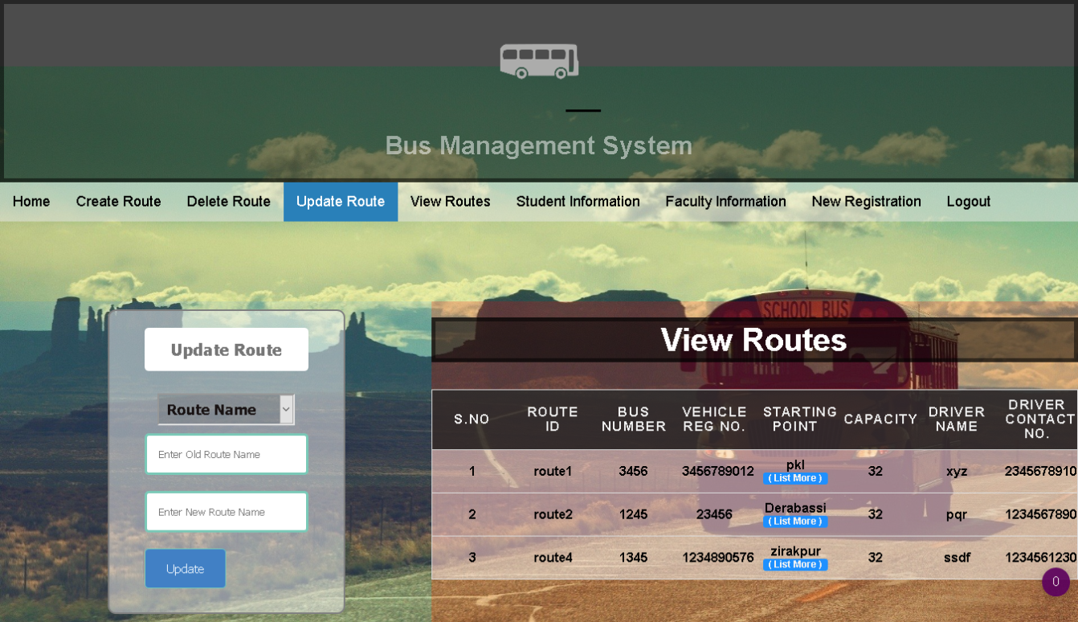

Figure 15 Update Route

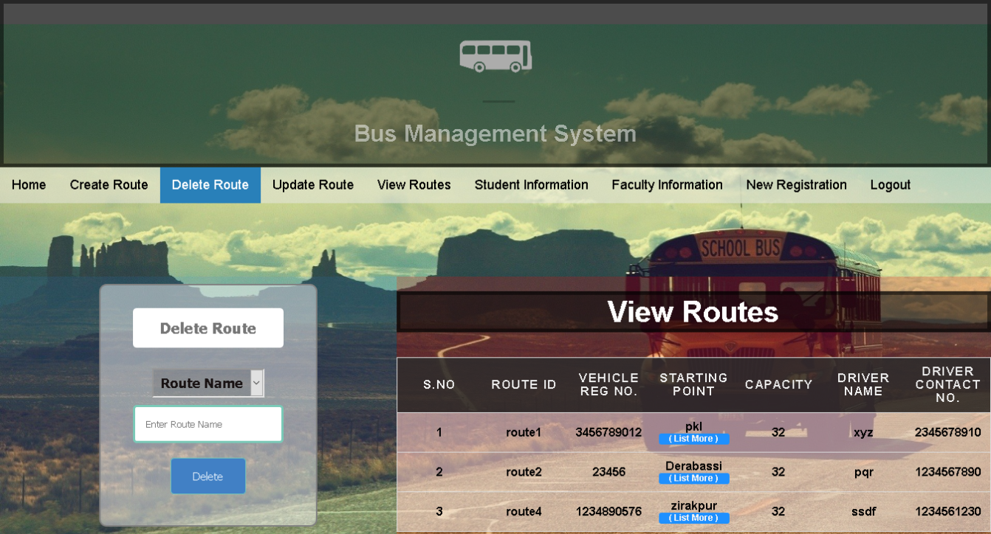

Figure 16 Delete Route

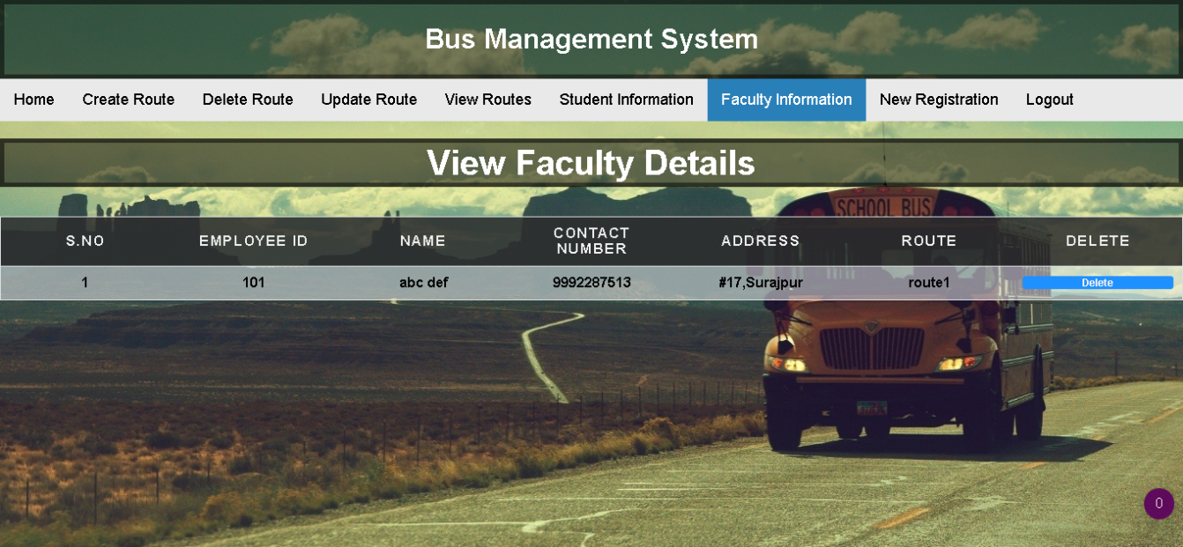

Figure 17 Faculty Details

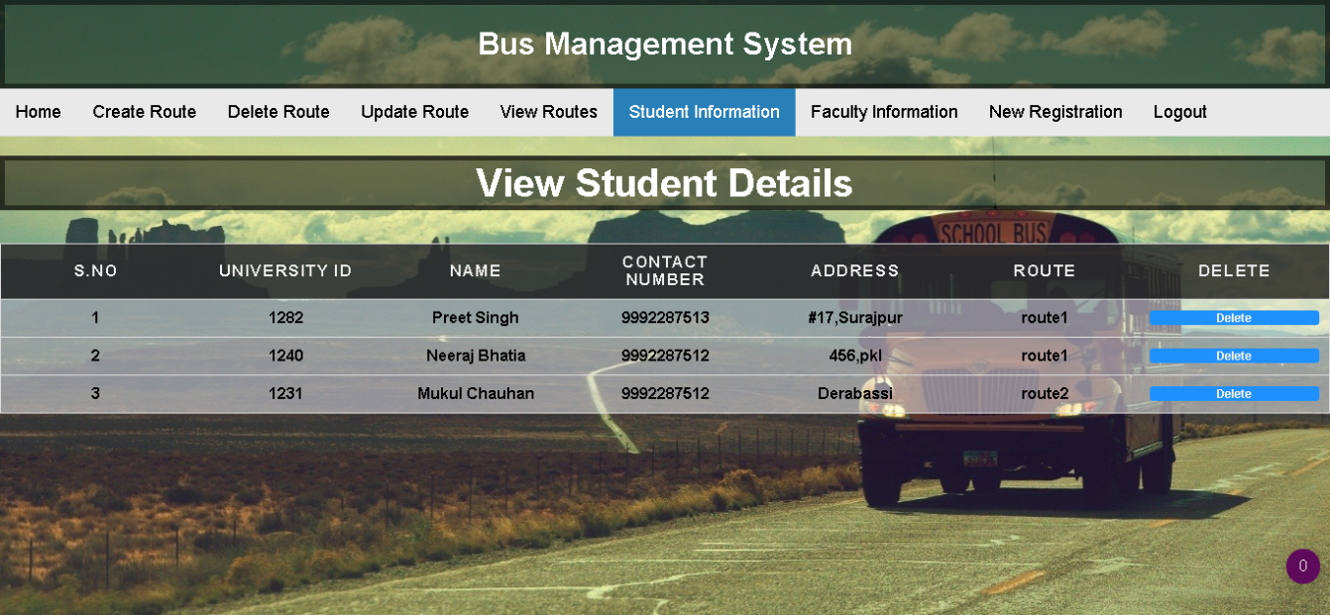

Figure 18 Student Details

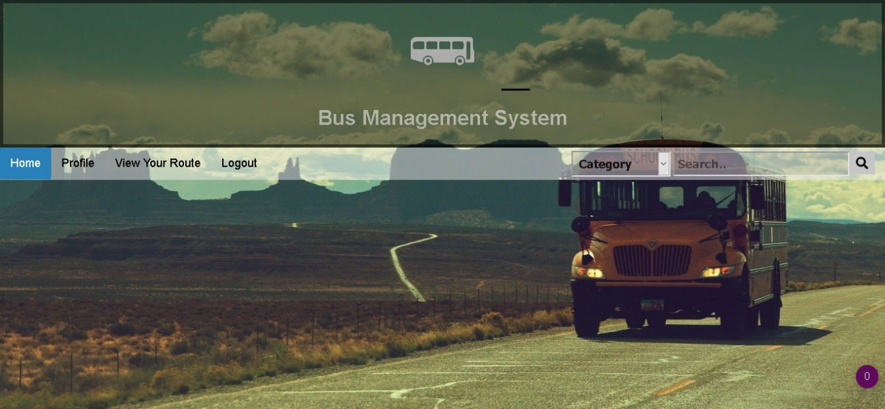

Figure 19 Student Dashboard



Figure 20 Faculty Dashboard

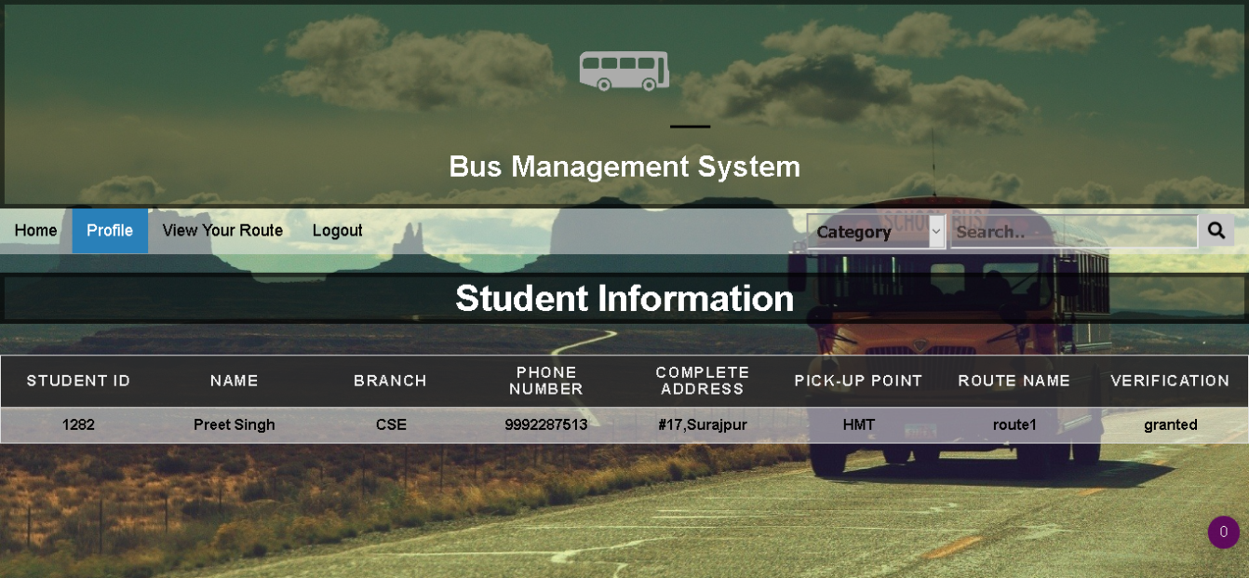

Figure 21 Student Information

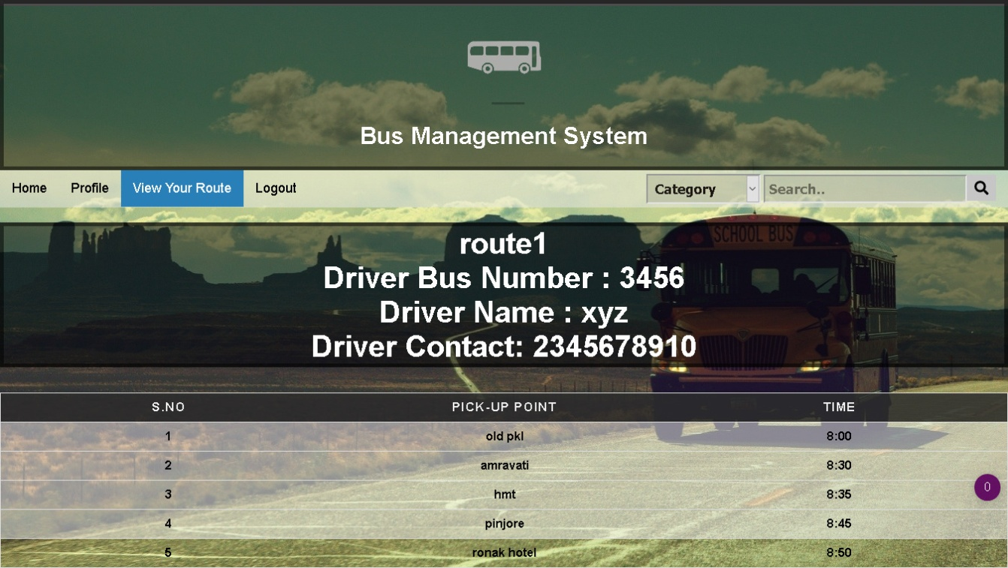

Figure 22 Route Info

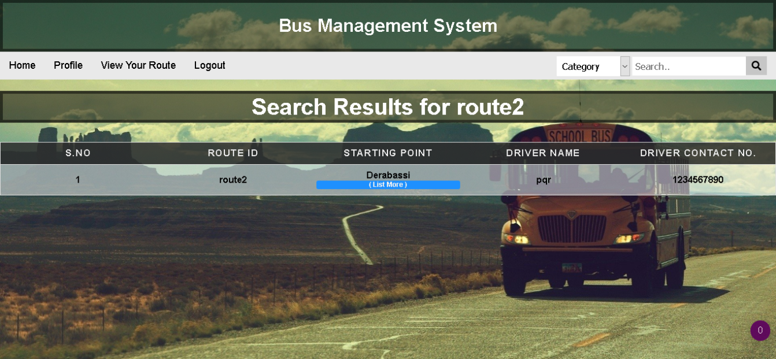

Figure 23 Search Results

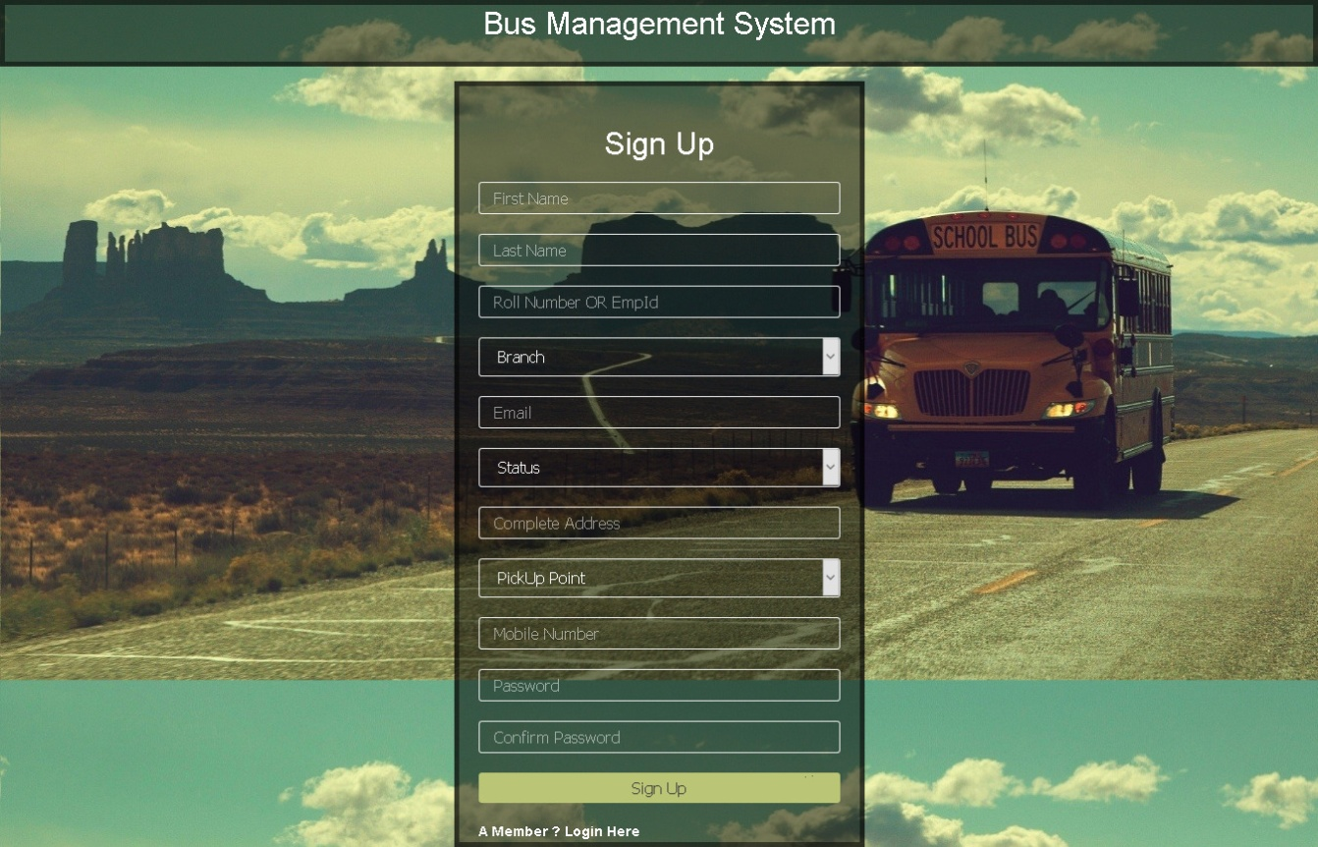

Figure 24 Sign-Up

**Chapter 5 SYSTEM TESTING**

**5.1 INTRODUCTION**

Testing is very important and critical to the success of any project that aims at delivering working software. There are many types of testing that a system may be subjected to, however only the ones in the testing objectives will be carried out for this system.

The overall purpose of testing is to ensure the Bus Management System meets all of its functional and business requirements. The purpose of this chapter is to describe the overall test plan and strategy for testing the system.

The goals in testing this system include validating the quality, usability, reliability and performance of the application. Testing will be performed from a black-box approach. Tests will be designed around requirements and functionality.

**5.1.1 CONFIRMATION TESTING**

Confirmation testing or re-testing: When a test fails because of the defect then that defect is reported and a new version of the software is expected that has had the defect fixed. In this case we need to execute the test again to confirm that whether the defect got actually fixed or not. This is known as confirmation testing and also known as re-testing. It is important to ensure that the test is executed in exactly the same way it was the first time using the same inputs, data and environments.

**5.1.2 REGRESSION TESTING**

During confirmation testing the defect got fixed and that part of the application started working as intended. But there might be a possibility that the fix may have introduced or uncovered a different defect elsewhere in the software. The way to detect these **‘**unexpected side-effects**’** of fixes is to do regression testing. The purpose of a regression testing is to verify that modifications in the software or the environment have not caused any unintended adverse side effects and that the system still meets its requirements. Regression testing are mostly automated because in order to fix the defect the same test is carried out again and again and it will be very tedious to do it manually. Regression tests are executed whenever the software changes, either as a result of fixes or new or changed functionality.

**5.1.3 TESTING RESULTS**

The Test Plan is derived from the Requirements, Functional Specifications, and detailed Design Specifications. The Test Plan identifies the details of the tests, identifying the associated test case areas within the product.

|  |  |  |  |  |  |  |
| --- | --- | --- | --- | --- | --- | --- |
|  | **Test Case** | **Test Purpose** | **Test Condition** | **Expected** | **Actual Result** |  |
|  |  |  |  | **Outcome** |  |  |
|  |  |  |  |  |  |  |
|  | Login | Check username | If user details are | Grant Access to | User successfully |  |
|  |  | and | not correct, | the | logs into the |  |
|  |  | Password | display error | applicable main | system upon |  |
|  |  |  | message | system | submission of |  |
|  |  |  |  |  | correct login |  |
|  |  |  |  |  | credentials. |  |
|  |  |  |  |  |  |  |
|  | Add new Student | To ensure that a | If user already | New user should | If email address |  |
|  |  | new student is | exists in the | be successfully | entered already |  |
|  |  | added to the | system, error | added to the | exists in the |  |
|  |  | System | message should | system. | System, error |  |
|  |  | successfully. | Display. |  | Message is |  |
|  |  |  |  |  | displayed. If the |  |
|  |  |  |  |  | email address of |  |
|  |  |  |  |  | the new |  |
|  |  |  |  |  | employee does |  |
|  |  |  |  |  | not exist in the |  |
|  |  |  |  |  | system, new |  |
|  |  |  |  |  | employee is |  |
|  |  |  |  |  | successfully |  |
|  |  |  |  |  | added. |  |
|  |  |  |  |  |  |  |

|  |  |  |  |  |  |  |
| --- | --- | --- | --- | --- | --- | --- |
|  | Edit details | To ensure that | On the edit | When the form is | Once the data in |  |
|  |  | once different | details form | altered the details | the form is |  |
|  |  | details are | provide | should be altered | altered and the |  |
|  |  | provided on |  | in the database | submit button |  |
|  |  | the edit | different | and a | clicked the |  |
|  |  | personal | information | confirmation | details in the |  |
|  |  | details form | from what is | message of the | database are |  |
|  |  | and | currently | change should be | altered and a |  |
|  |  | submitted, | being | displayed. | Confirmation |  |
|  |  | these details | displayed |  | message of the |  |
|  |  | are altered in |  |  | change is |  |
|  |  | the database. |  |  | displayed. |  |
|  |  |  |  |  |  |  |
|  |  |  |  |  |  |  |
|  |  |  |  |  |  |  |
|  |  |  |  |  |  |  |

Table 1 Shows system test plan and results

**Chapter 6 CONCLUSION**

The aim of this chapter is to draw conclusions of the work done or achieved and to give an assessment of the completed system, discuss the Problems faced, limitations of the system and give future recommendations on how the system can be improved.

The software product produced was good, it achieved most of the user requirements, the user interface is good and is very easy to navigate, and even novice users can find their way around the web application easily. The client-side validation is excellent.The Problem with the attendance system is of storing the attendance of employees on daily basis because it needs a large amount of database space and maintenance.

Since this project has been designed exclusively as a project, certain complexities that do faced by any real life manual problem like total no. of students, address etc. are considered in this project. But enhancement to the project can easily be made without changing the current design and programming structure.

**Chapter 7 FUTURE SCOPE**

To make the system efficient for maintaining the databases and records of buses , drivers and all the commutersUtilization of this system will increase the productivity. The main moto of this is to provide transport service to consigner and consignee. As due to computerization billing, summarized payment, creating report etc. will be permanently stored and will be easily available whenever need in future. Consequently this will also decrease the work load in the office resulting in having more time investment in other productive tasks.

**Chapter 8 BIBLIOGRAPHY / REFERENCES**

References were taken from various websites to complete this project.

[www.google.com](http://www.google.com)

[www.quora.com](http://www.quora.com)

[www.slideshare.com](http://www.slideshare.com)

[www.pockethrms.com](http://www.pockethrms.com)